Estuaries
https://www.youtube.com/watch?v=t8WN3DvfDWM
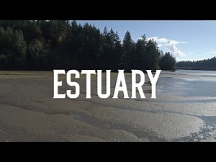 | Estuaries  Estuaries  www.youtube.com
-What makes estuaries unique?
-What benefit do estuaries provide?
-What are the threats to estuaries?

Blue carbon
https://www.youtube.com/watch?v=Vzn5XO_GYL0
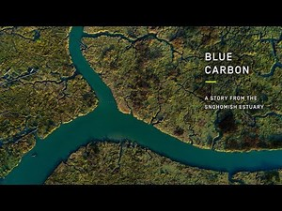 | Blue Carbon – A Story from the Snohomish Estuary  “Blue Carbon” is a story of how coastal wetlands mitigate climate change and reduce carbon pollution to benefit all people. This video, filmed in the Snohomish Estuary in Puget Sound, Washington is presented by EarthCorps and Restore America’s Estuaries. Learn more about restoring coastal wetlands at www.bluecarbon.us Learn how to get ...  www.youtube.com
-Why is it called blue carbon?
-How is carbon stored in estuaries?
-Are forests or wetlands better at storing carbon and why?

Rivers and Tides: Restoring the Nisqually
https://www.youtube.com/watch?v=bs7fsguISfk
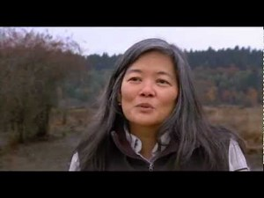 | Rivers and Tides: Restoring the Nisqually Estuary  Diked and dammed for more than 100 years, the tide is returning to the Nisqually estuary! This video highlights the largest estuary restoration in the Pacific Northwest with dramatic footage. Nisqually NWR, Ducks Unlimited and the Nisqually Indian Tribe worked tirelessly for more than 12 years with the help of many partners to restore 762 acres ...  www.youtube.com
-Why was the dike originally created?
-What were some challenges involved with removing it?
-How are the different species affected by the restoration process?
NERRs
https://www.youtube.com/watch?v=qrYQFdukGMg
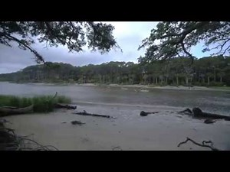 | Estuaries: Where the River Meets the Sea  Estuaries and their surrounding wetlands are bodies of water usually found where rivers meet the sea. Estuaries are home to unique plant and animal communities that have adapted to brackish water—a mixture of fresh water draining from the land and salty seawater. Estuaries are among the most productive ecosystems in the world. Many animals ...  www.youtube.com
-What is the National Estuarine Rsearch Reserve (NERR) system?
-Who manages the NERRs?
-What is the closest NERR to us?

